Job description
Speaker Liaison

Job description
- Work with your teacher and list the people who could be speakers.
- Invite these speakers to the event by writing a letter.
(your teacher has an invitation for you to adapt)
- Follow-up to check the speakers can come to the event.
- Offer help to the speakers.
- Check that the speaker is well briefed about the event.
- Manage any crisis such as a speaker pulling out at the last minute.
- Write thank-you letters to speakers after the event.

Selection criteria
Essential skills and knowledge
- Good interpersonal and teamwork skills: You are good at working with other people.
- Organisational and time management skills: You are organised and do things on time.
- Good written and oral communication skills: You are good at writing and speaking to people.

Desirable skills and knowledge
- Ability to stay calm and manage unexpected changes.

Address the selection criteria Speaker Liaison

Step 1. Think about the job
- Read the job description.
- Read the selection criteria.

Job description
- Collaborate with your teacher and identify people who will be suitable speakers.
- Invite these speakers to the event by writing a letter.
- Follow-up to check the speakers can come to the event.
- Offer help to the speakers.
- Check that the speaker is well briefed about the event.
- Manage any crisis such as a speaker pulling out at the last minute.
- Write thank you letters to speakers after the event.

Selection criteria
Essential skills and knowledge

Skills that you must have.
- Good interpersonal and teamwork skills.
- Organisational and time management skills.
- Good written and oral communication skills.
Desirable skills and knowledge
Skills that are good to have.
- The ability to stay calm and manage unexpected changes.

Read the selection criteria again
☑ Tick those skills that you have.

Step 2. Address the selection criteria
Look at this example:
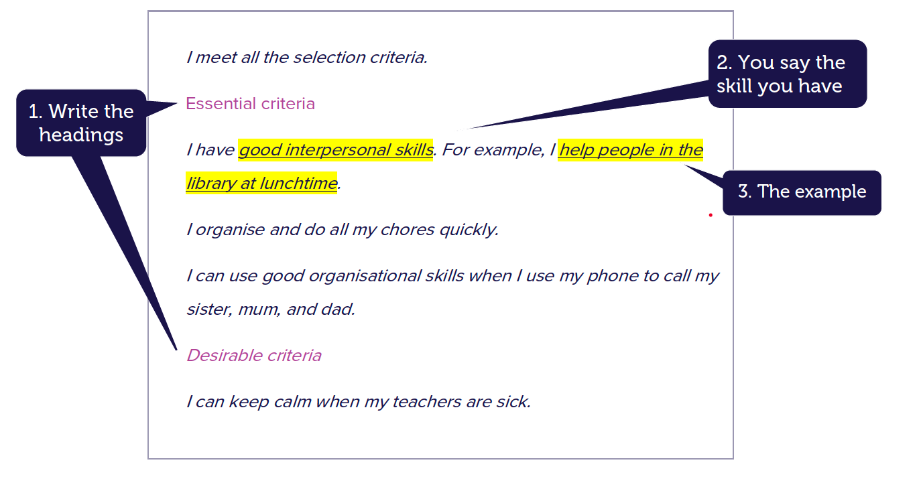
Now write how you meet the selection criteria on a separate sheet of paper.
Write about each skill and knowledge listed in the selection criteria.
- Use headings.
- Write a sentence that says the skill that you have.
- Write a sentence about when you have used this skill.

Step 3. Write a covering letter
Read this example:

Dear Mr Smith,
My name is Julie Harding and I would like to apply for the role in Event Promotion.
I have written how I meet the selection criteria and include my resume.
I would really like to be considered for this role because I am good at drawing. Your sincerely,
Julie Harding

Now write your covering letter on a separate sheet of paper.
Write about:
- Who you are.
- What job you are applying for.
- What documents you are giving them.
- A sentence about why you will be good at the job.

Step 4. Make your job application
Put these 3 documents together:

- Covering letter that you have written.
- Your address to the selection criteria document.
- Your resume.
- Give your application to your teacher.

My work plan

As the , my job will be

- ________________________________________________________________
- ________________________________________________________________
- ________________________________________________________________
- ________________________________________________________________
- ________________________________________________________________

People who can help me

- ________________________________________________________________
- ________________________________________________________________
- __________________________________________________________________________________

