Unit plan: Post-school options:
Self-discovery
Each PLAN section will function as your lesson plan.
You will be able to download and print out any student worksheets.
Each PLAN section will include links to the relevant part of the myWay Employability website.
For further information on appropriate adjustments to meet the learning needs of your students, see the Teacher notes: Teaching to diversity using myWAY Educator.
* Activity duration are approximate times only.

Learning objectives & activities to achieve these: Self-discovery
Objectives | Activities | Lesson elements
Lesson One: Explore Career Interests
Students will learn relevant vocabulary.  Students will identify their preferences and important considerations when choosing a career. | 1. Pre-teach vocabulary | Pre-teach vocabulary using the glossary activities (if required).
 | 2. Introduction to career interests  10-15 minutes approx.  Teacher summary  Summarise the activity by concluding that there are many considerations to take into account when thinking about careers. Also, that people often change their mind during their career journey and that that’s OK. However, finding a job that matches our strengths and interests are important considerations. Today’s lesson is about exploring career interests. | Facilitate the following whole-class brainstorm.  Whole-class Brainstorm  What do you think are important things to think about when you are choosing a career?  Explain the rules of brainstorm and invite responses to the question.  Place one sample answer on the board to give them an idea of the kind of response that is suited.  Nominate a student scribe for the activity.  Sample answers:  - How much you can earn in that career.  - Whether it’s a good match for your interests.  - Whether there are good job prospects in that career.  - Whether it’s a good match for your skills and abilities.  - How long you have to study to get a job in that career.  - Whether there are jobs where you live.  - Whether you can travel or live in other countries with that career (if this is something that you want to do).  Prior learning activity: for students who require additional assistance to understand their likes and dislikes or need assistance distinguishing between types of activities and their preferences, there are three scaffolded 20 Questions activities that can support this understanding available in the Plan section.
Students will hear real-life accounts of career journeys. | 3. Explore careers  10-15 minutes approx. | Exploring interest-led careers  inclusionED contains some video content of people talking about their study and career journeys, and how they have made a career from following an interest or a personal strength.  View Selfie videos in the Plan section.  Use the Video note-taking chart to assist students to take notes whilst viewing (download from Plan section).  Afterwards, invite responses to the videos with a whole-class discussion.  Example discussion prompts:  - From the jobs described, is there a job that appeals to you? Why?  - Is there any advice from the videos that you find particularly interesting? Surprising? Why?
Students will be introduced to the myWAY Employability website.  Students will create a login to the website. | 4. Introduction to the myWAY Employability website  5–10 minutes approx.  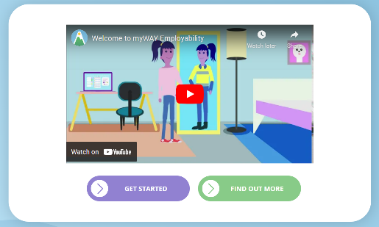 | myWAY Employability website  Watch the introduction video (pictured on the left) on the myWAY Employability homepage as a whole class and explain that all students will be using the website over the coming term/year.  Allow students free time to set up their individual log-ins. Move around the class to assist as needed.
Students will explore their career interests. | 5. Explore interests  10-20 minutes approx.  Important points to convey  - Students can take their time to answer questions.  - There are no right or wrong answers.  - This is an individual activity. | Explore your own interests  Introduce the myWay Employability Career Exploration quiz (first quiz on the left-hand side of My Dashboard page). Demonstrate if needed.  Allow time for students to complete the activity in class.  When they have finished the quiz  Finish times will be staggered; encourage them to quietly share their thoughts with a partner.
Prepare for next lesson |  | If using the My Strengths worksheet for the next lesson, set this as homework..

myWAY Employability site: Login and Career Exploration section
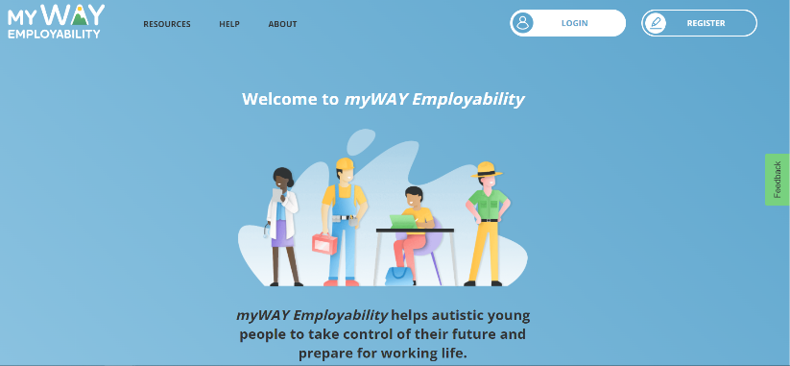  Image: the homepage for myWAY Employability. | 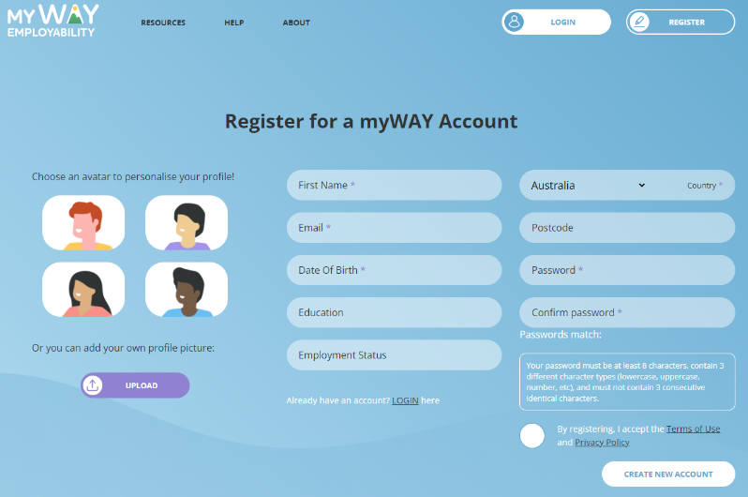  Image: the registration page for myWAY Employability.
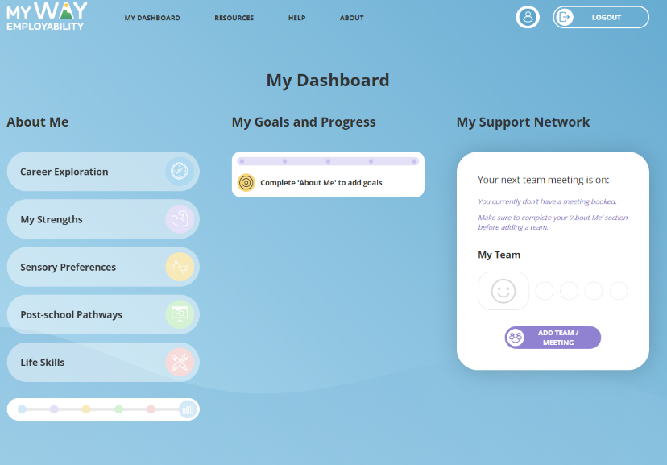  Image: My Dashboard section for myWAY Employability. Quizzes to be completed are on the left-hand side. | 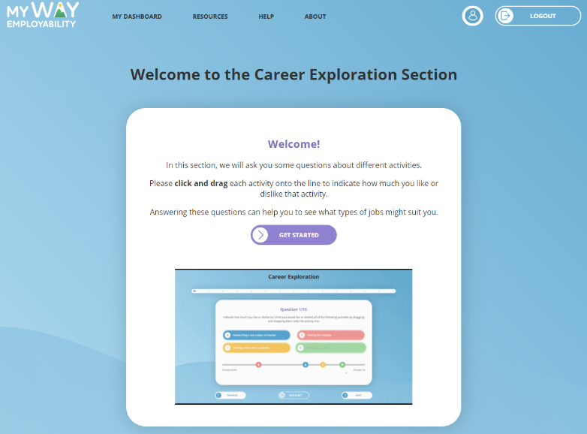 Image: welcome image for Career Exploration section explaining how to answer the questions.
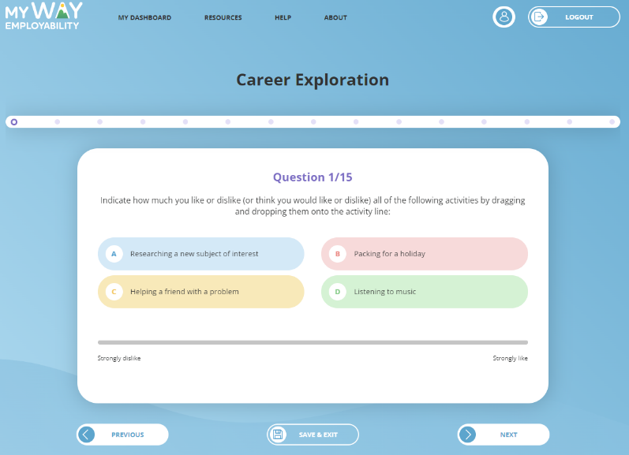  Image: an example question from the Career Exploration quiz. | 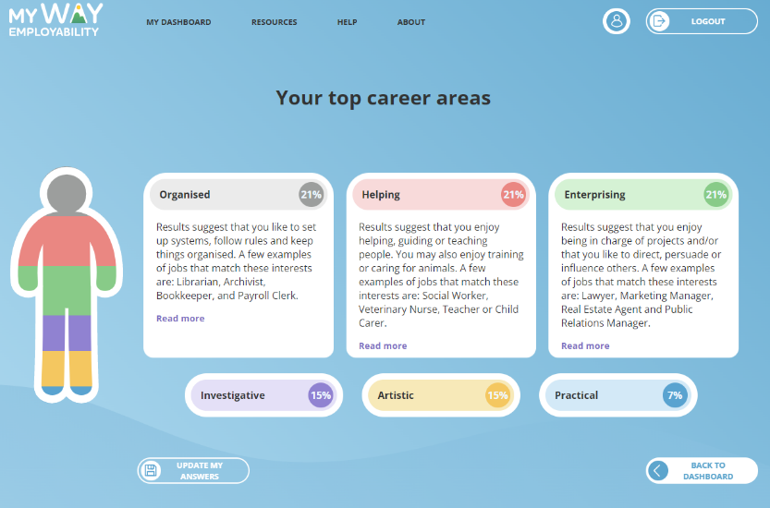  Image: an example results page from the Career Exploration quiz.

Objectives | Activities | Lesson elements
Lesson Two: Explore Student’s Strengths
Students will explore their strengths. | 1. Student strengths worksheet  10–15 minutes approx. | If using the My strengths student worksheet this task should have been set in the week prior.  Ask students to discuss the findings of their worksheet with a partner.  Whole of class discussion: How did you find doing the My strengths student worksheet?  Sample answers:  - Interesting to get other people’s perspectives.  - I learnt more about myself.  - Made me feel positive about myself.
Students begin to recognise their strengths. | 2. Recognising strengths  20–30 minutes approx. | Prior to the lesson, print out this Multiple Intelligences Assessment and choose approximately 20 statements (depending on time) that you will quiz the class on to help them begin to recognise their strengths.  Print out agreement statements (Strongly Agree, Agree, Neither Agree nor Disagree, Disagree, Strongly Disagree) and either:  - Post these along a wall  - Place them along the floor in a straight line  - Place them in separate corners of the classroom  You will then tell the students that you will announce a statement, and they must move to where they feel it aligns with their strengths. Some students may require further explanation of the concepts. It is important to stress that their strengths may be different from their friend’s strengths.
Students begin to understand how different career choices align to different strengths. | 3. Explore strengths  10-20 minutes approx.  Important points to convey  - Students can take their time to answer questions.  - There are no right or wrong answers.  - This is an individual activity. | Introduce the My Strengths Quiz  Introduce the myWay Employability My Strengths quiz (second quiz on the left-hand side of My Dashboard page). Demonstrate if needed.  Allow time for students to complete the quiz in class.  When they have finished the quiz  Finish times will be staggered; encourage them to quietly share their thoughts with a partner.

myWAY Employability site: My Strengths section
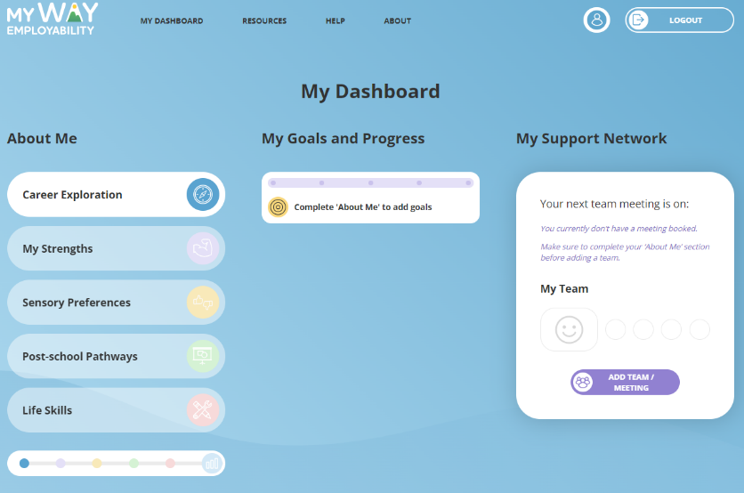  Image: the My Dashboard page after the Career Exploration quiz is completed. | 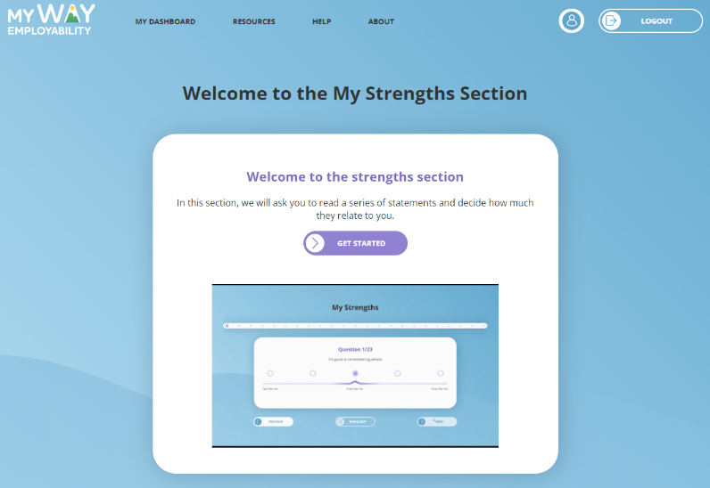  Image: welcome image for My Strengths section explaining how to answer the questions.
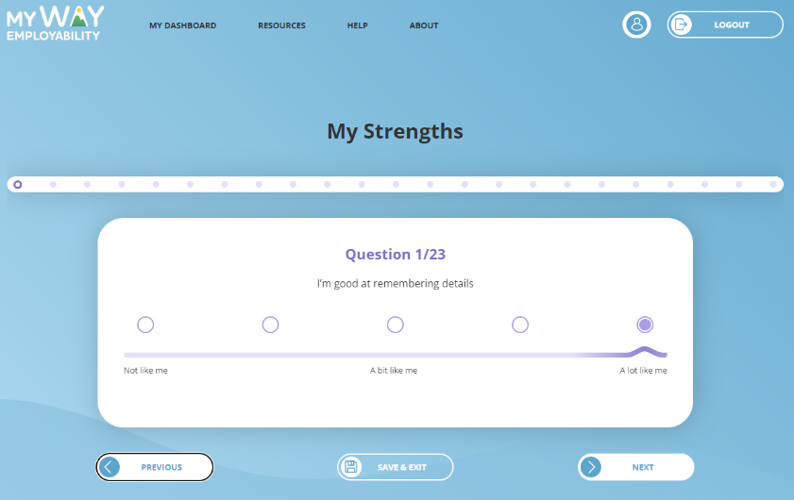  Image: an example question from the My Strengths quiz. | 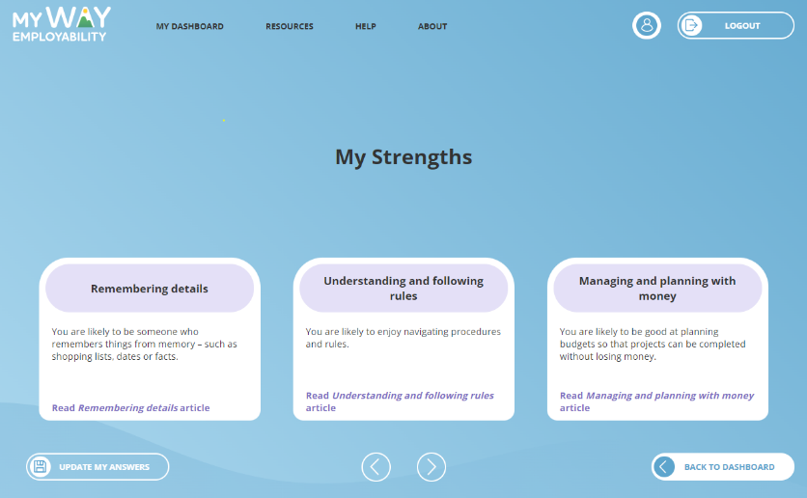 Image: an example results page from the My Strengths quiz.

Objectives | Activities | Lesson elements
Lesson Three: Explore Sensory Preferences
Students will understand what sensory preferences are. | 1. Introduce learning styles  10–15 minutes approx. | Understanding sensory preferences also means understanding the way you prefer to learn. Play this video (Discover Your Learning Style) to explain the four learning styles a student may prefer.  Students can discuss with a partner about which learning style they think they prefer.
Students will understand how sensory preferences can help them make decisions about their career path. | 3. Explore sensory preferences  10–20 minutes approx.  Important points to convey  - Students can take their time to answer questions.  - There are no right or wrong answers.  - This is an individual activity. | Introduce the My Strengths Quiz  Introduce the myWay Employability Sensory Preferences quiz (third quiz on the left-hand side of My Dashboard page). Demonstrate if needed.  Allow time for students to complete the quiz in class.  When they have finished the quiz  Finish times will be staggered; encourage them to quietly share their thoughts with a partner.

myWAY Employability site: Sensory Preferences section
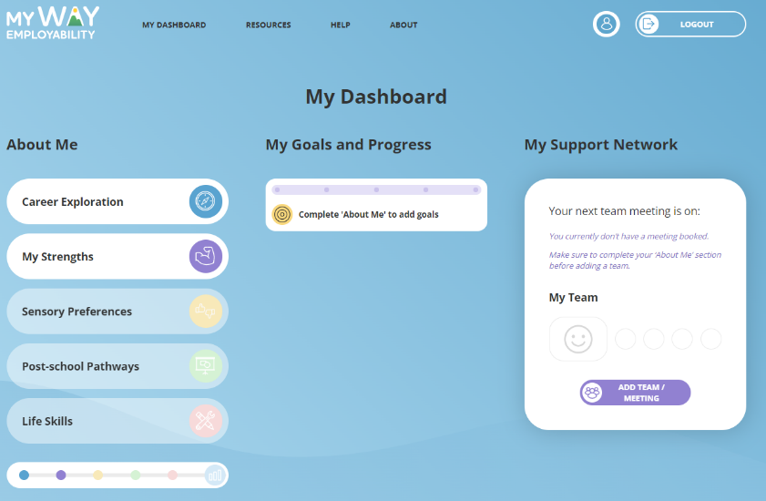  Image: the My Dashboard page after the My Strengths quiz is completed. | 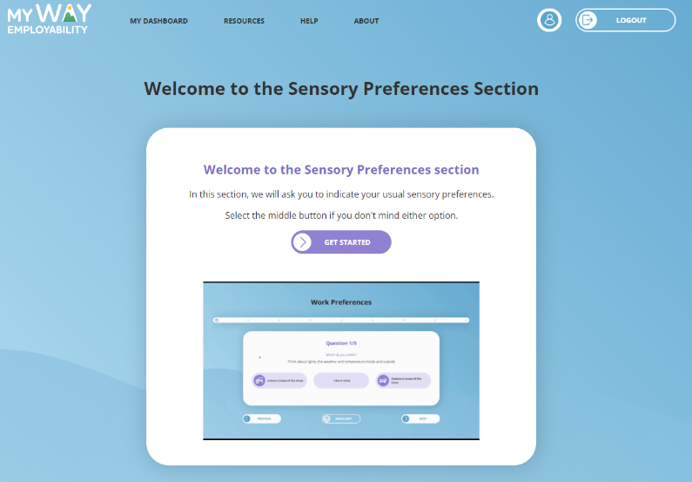  Image: welcome image for Sensory Preferences section explaining how to answer the questions.
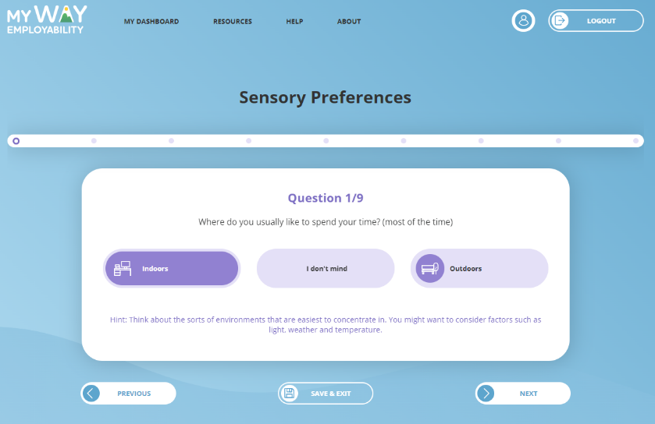  Image: an example question from the Sensory Preferences quiz. | 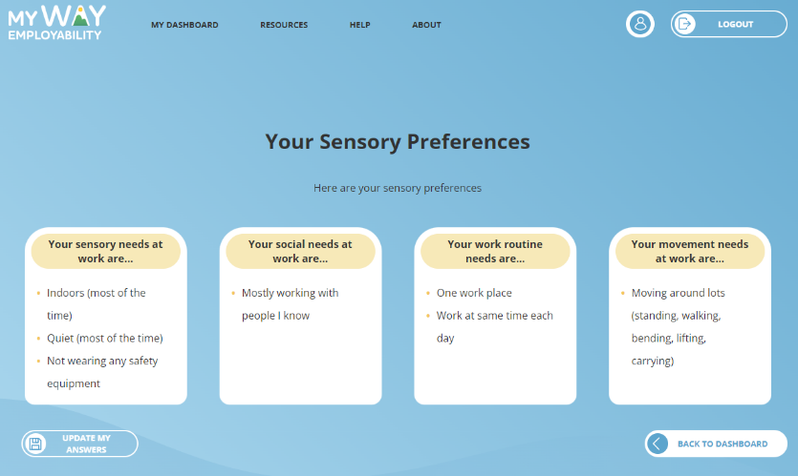Image: an example results page from the Sensory Preferences quiz.

